Higher Diploma in Computing

Project

DESIGN
Student: Niall Coffey
Project Title: Cheap As Chips

Student No: x00124473

Suggested database design July 2016

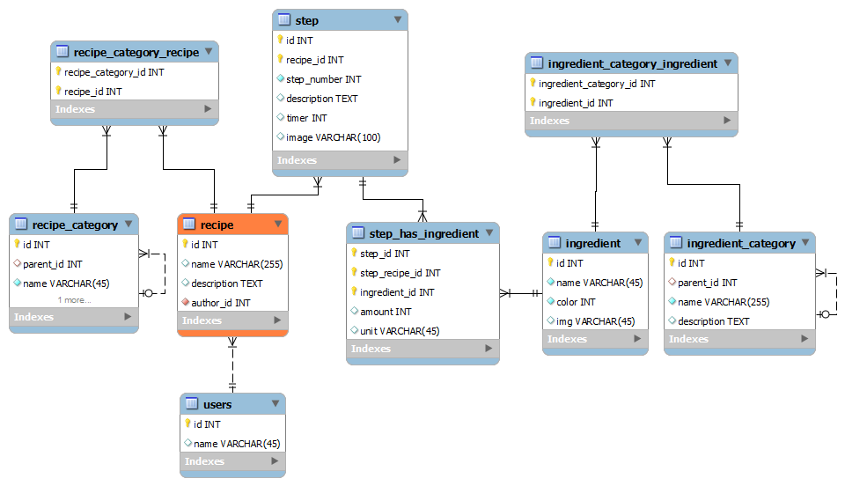

Final Model classes

